Not Seeing an Expected Section in the Content Plan?
A common example is you are not seeing a Clinical Study in a particular section of the Content Plan or it exists in the wrong section of the Content Plan and you want to correct it.
First get an understanding of Relationships and their Impact to the SCP Structure.

In this example, we have a Clinical Study which is tagged with a Study Type of Biopharmaceutical and Subtype of Bioanalytical and Analytical Methods:
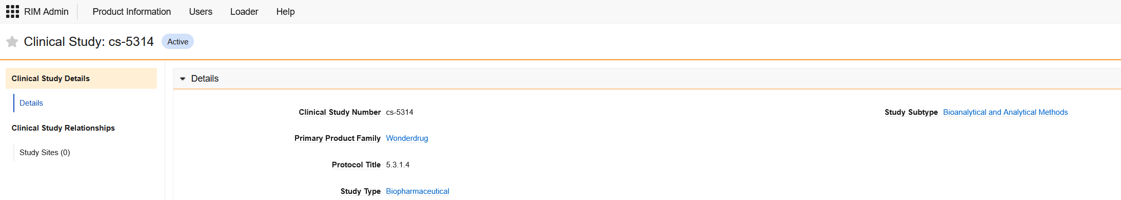

Our corresponding Application is related to this Clinical Study:
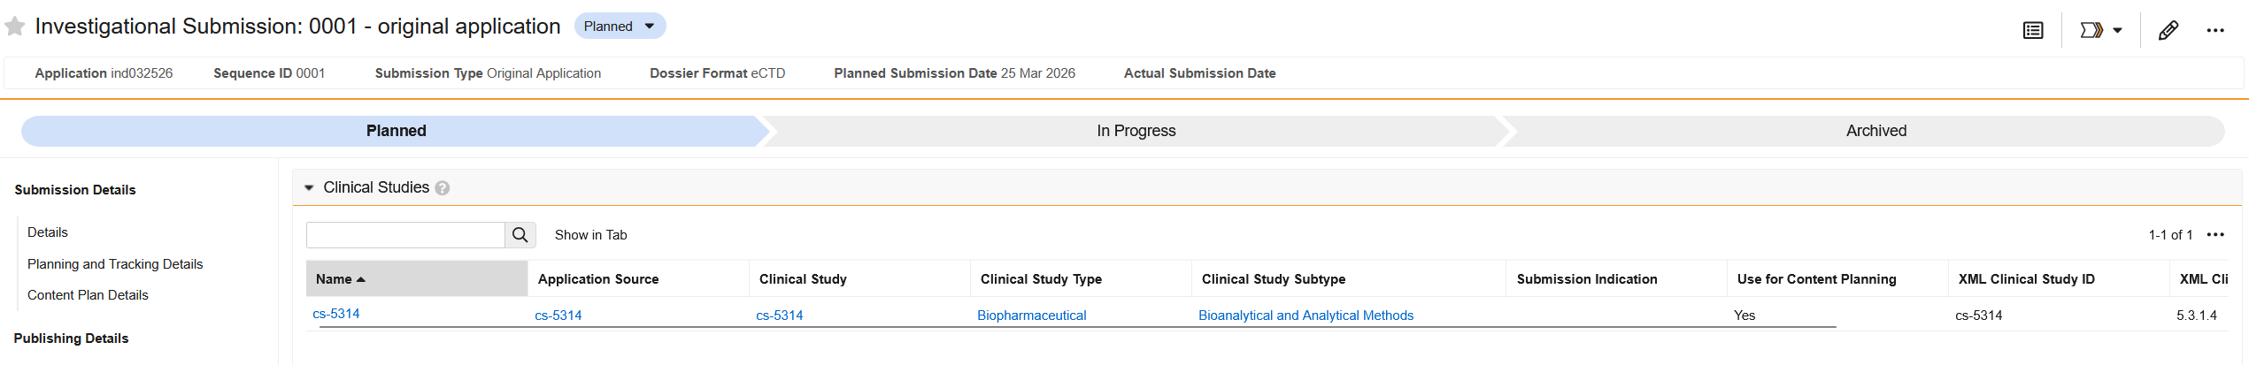
Our Regulatory Objective also is related to this Clinical Study:
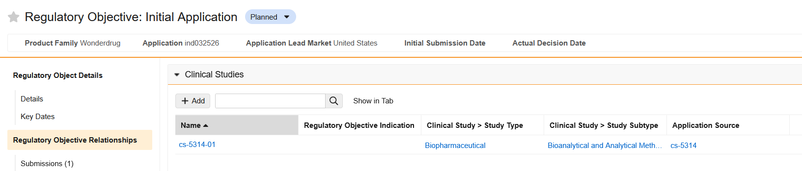
Our Submission also is related to this Clinical Study:
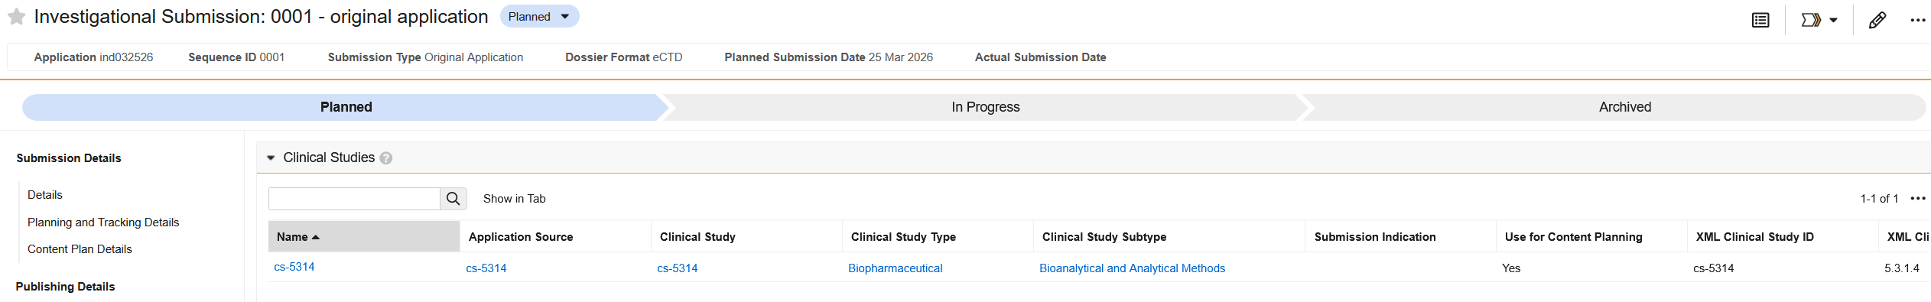

Lastly, we have a Content Plan that has this Study in it, in its corresponding 5.3.1.4 section:
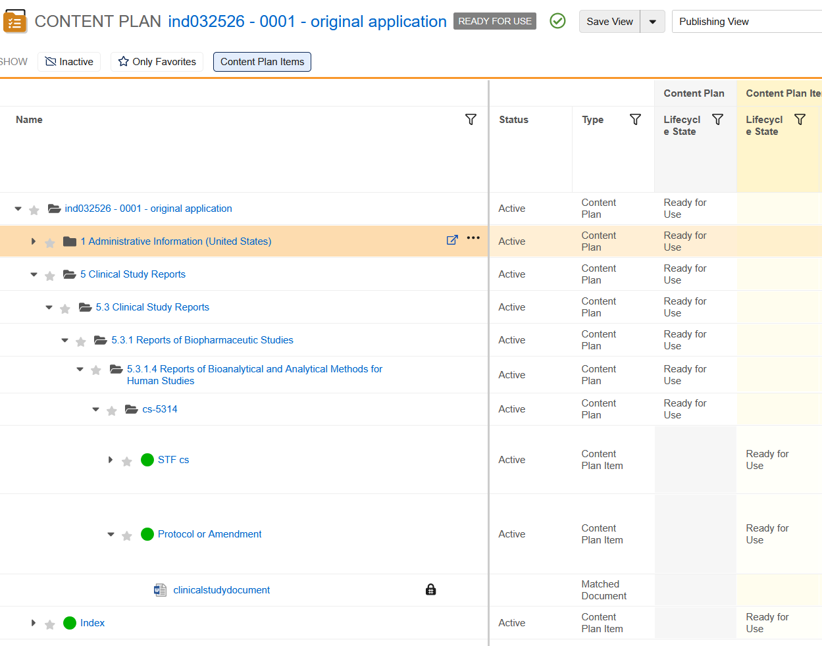
For this example, we’ll say that we notice we did not want study cs-5314 to be in Section 5.3.1.4, but we want it to be in 5.3.5.4.

To correct that, we cannot just delete the relationship on the Submission:
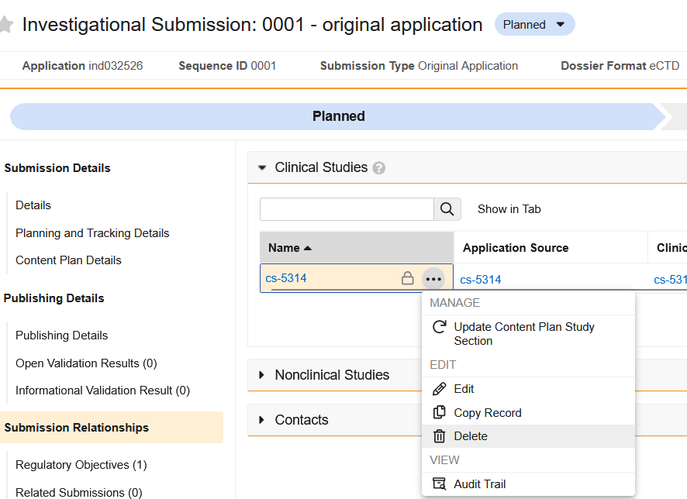
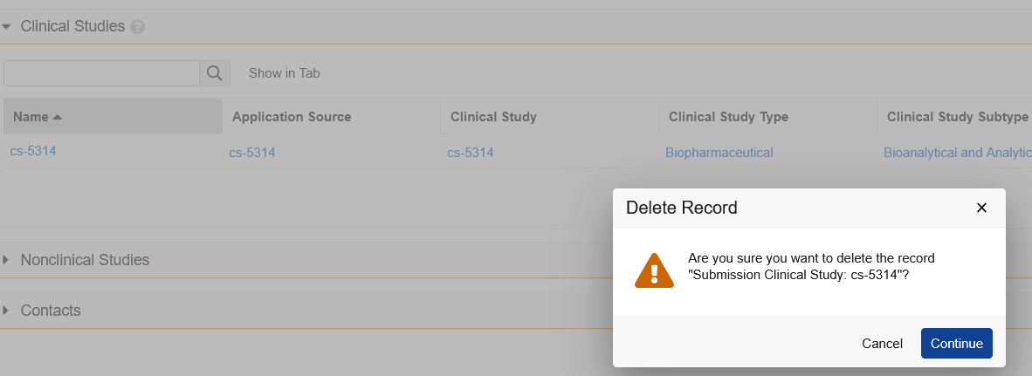
The system will inform you that this study is in use in the Content Plan (which it is):
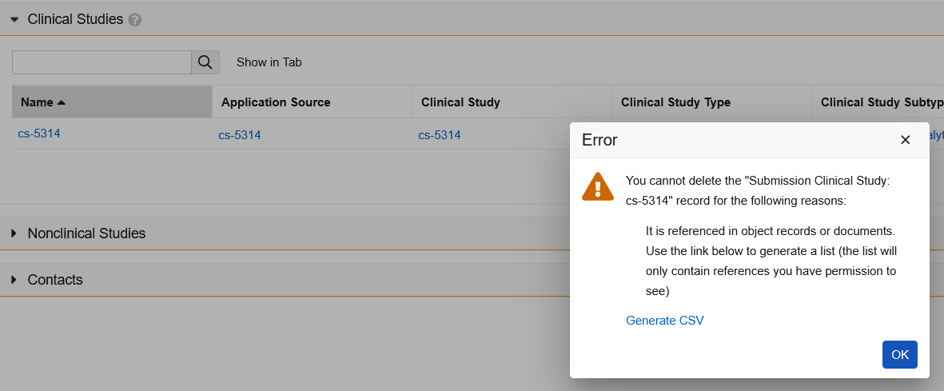

So we will first delete the corresponding section of the Content Plan (which it may be active or inactive). In our example, it is active.
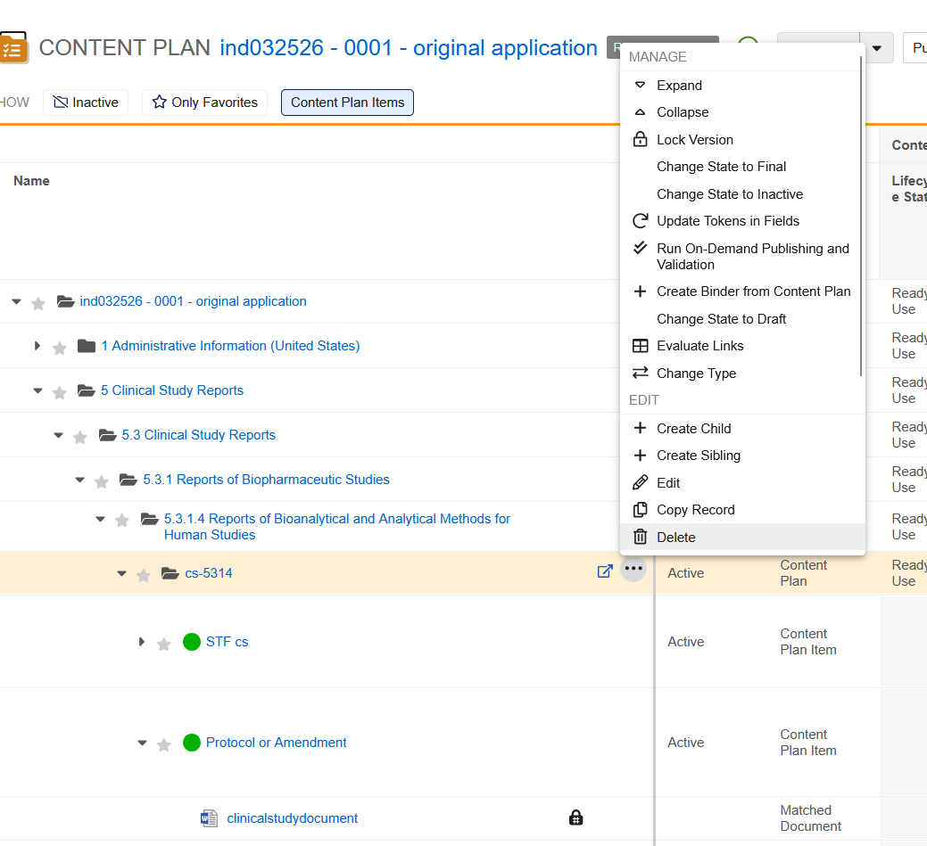
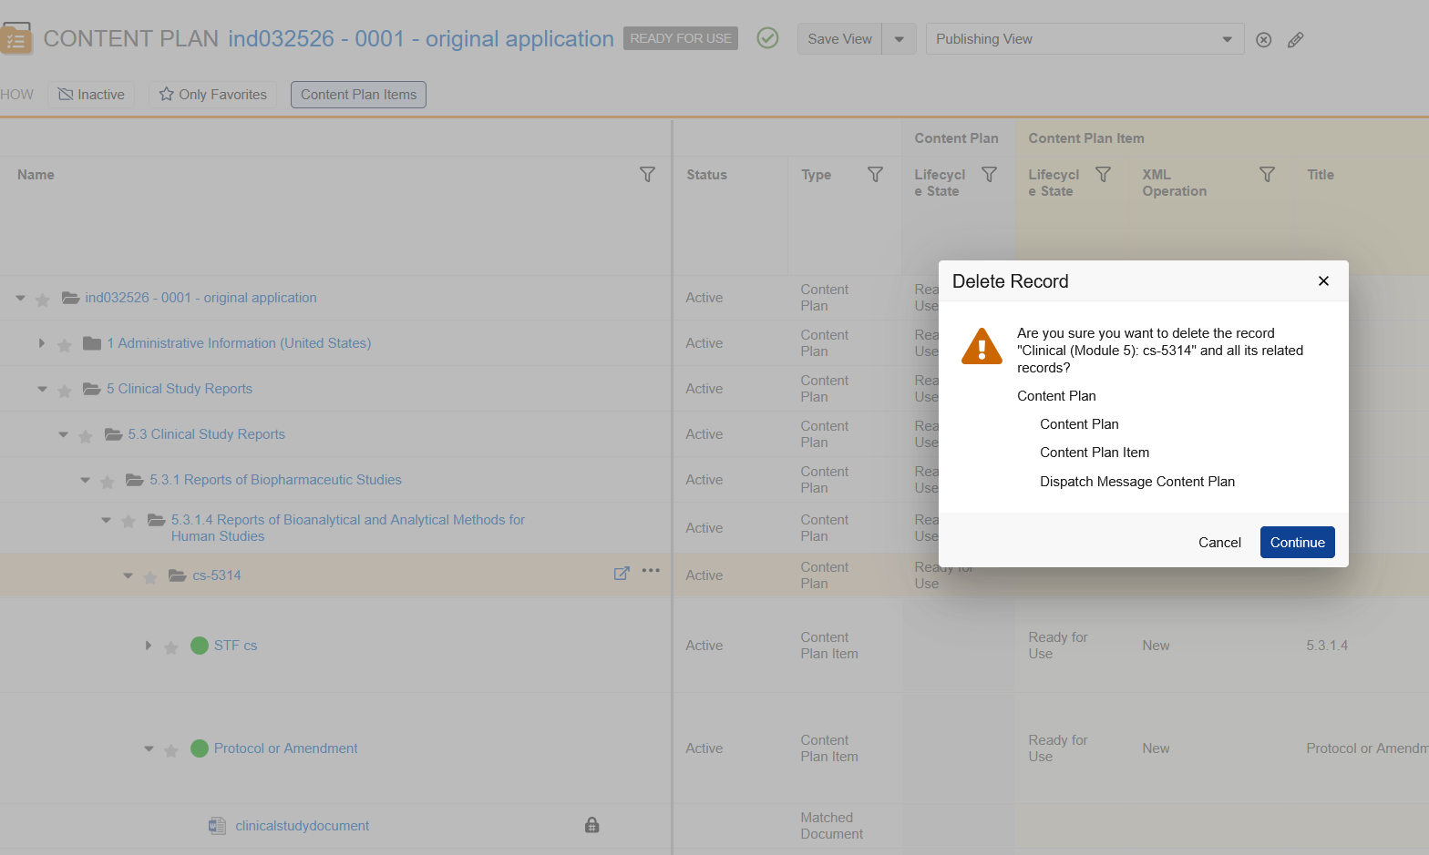
It should then be removed (you can verify it is not there even when showing inactive items):
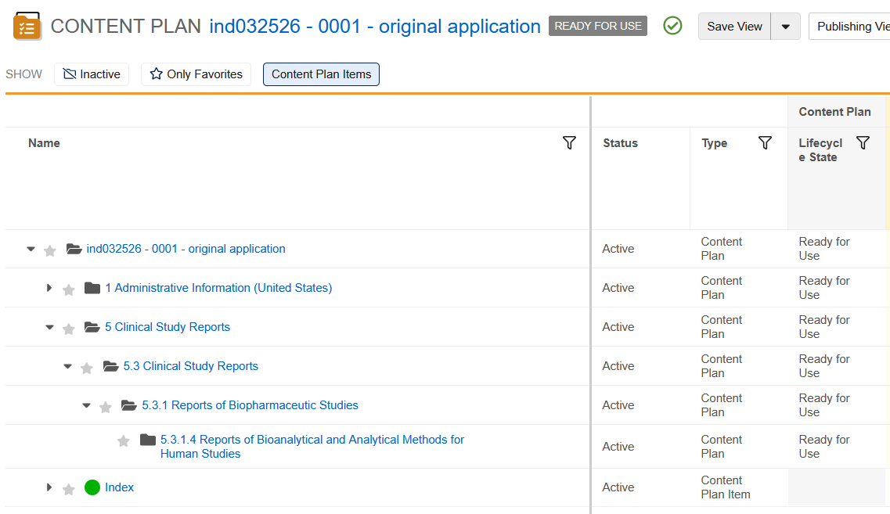

Next, we will want to temporarily remove the link from this Submission relationship to the Application by temporarily clearing the Application Source field (this will also need to be done on every submission that uses this Clinical Study):
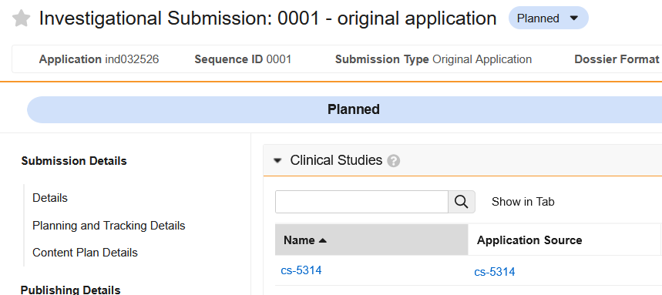
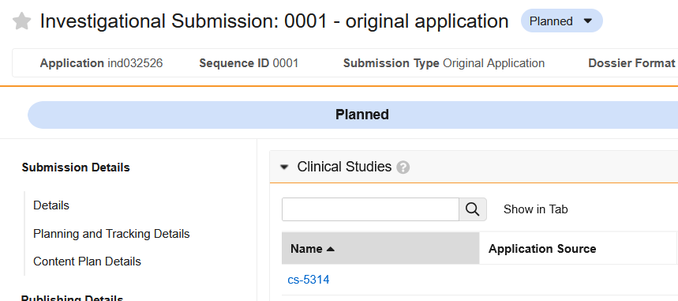
We’ll do the same on all the Regulatory objectives that use this Clinical Study:
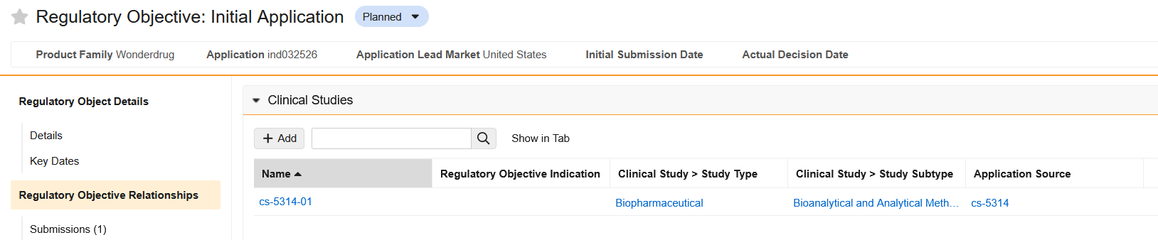
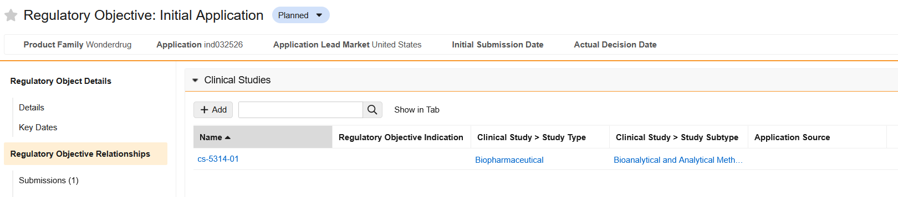

We can then update the Application Clinical Study record (updating the Clinical Study Type, Clinical Study Subtype, and populating the Application Indication):
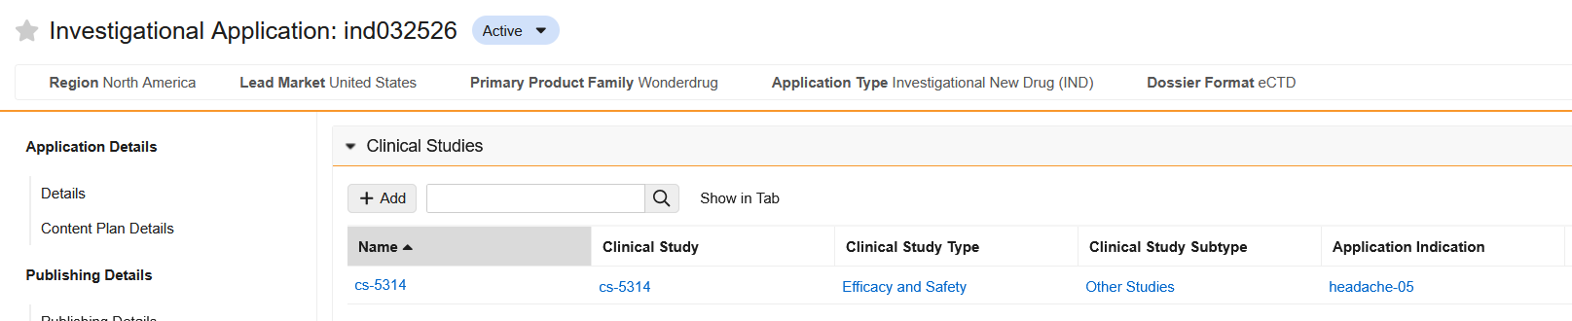
If it is in the 5.3 section, you will need to first ensure you an have an indication relationship on your Application (as you cannot populate the Application Indication portion of a Clinical Study without it):
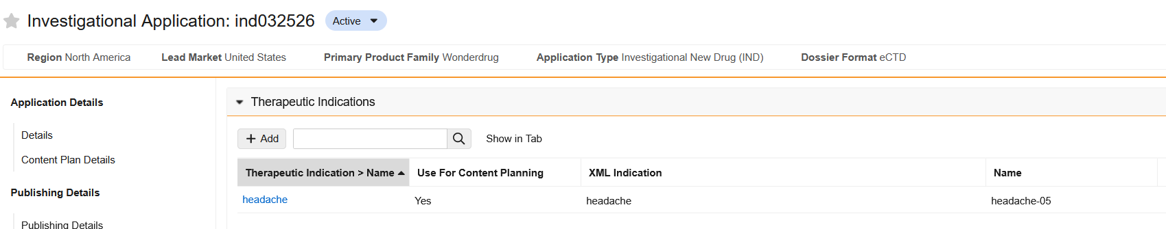

If you want to permanently update the Clinical Study type and subtype, your Vault Admin can make that update on the Clinical Study record itself (so future Applications which use this study now reflect the updated Clinical Study Type and Clinical Study Subtype):
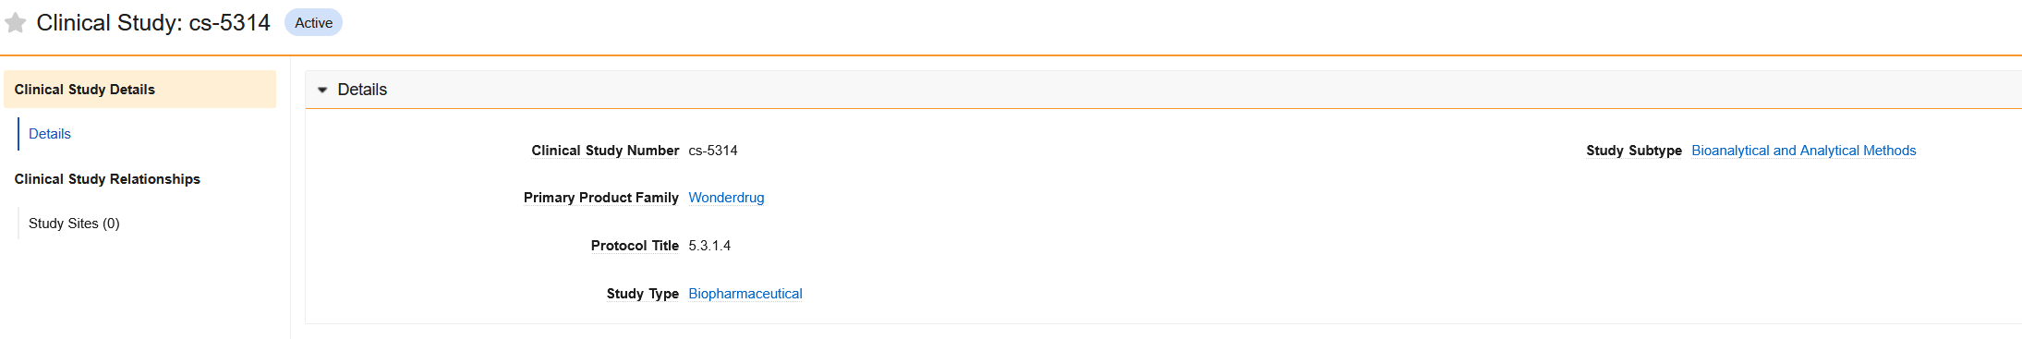
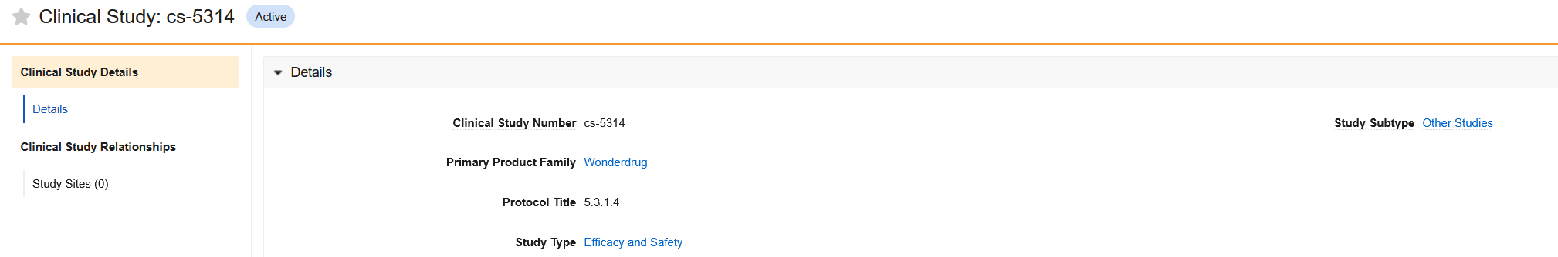
You can then go back to the Regulatory Objectives that utilize that Clinical Study and re-populate the Application Source field:
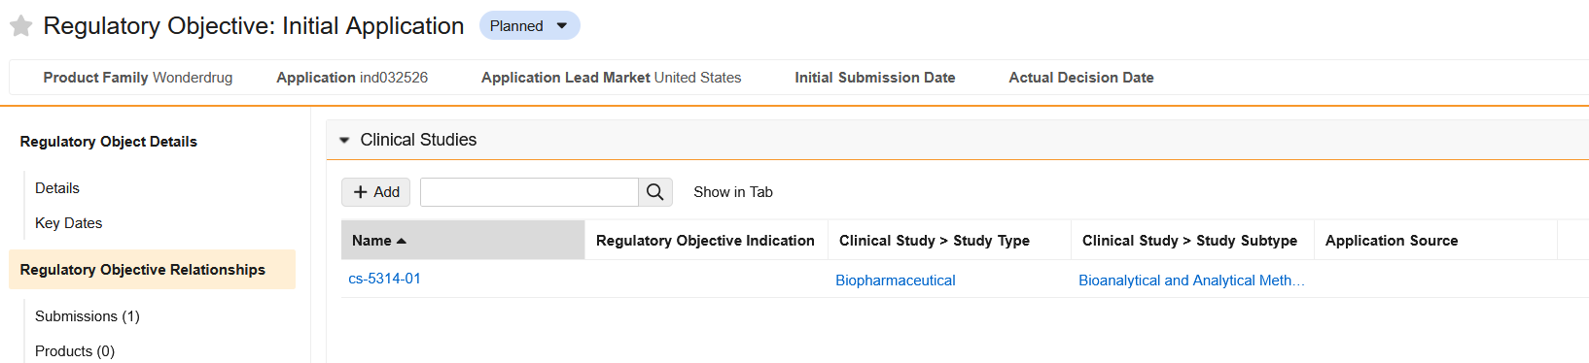
Upon doing so, the Study Type and Subtype should be updated automatically:
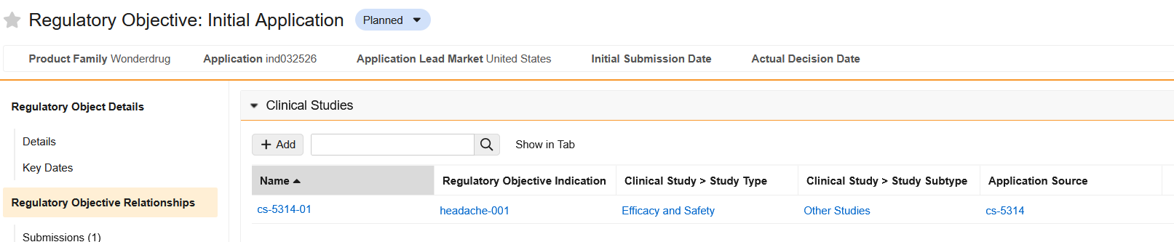

You can then go back to the Submissions that utilize that Clinical Study and also re-populate the Application Source field:
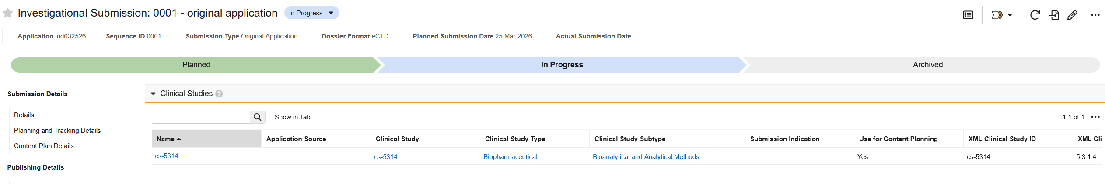
When doing so, the Study Type, Subtype, and Submission Indication should be updated automatically:
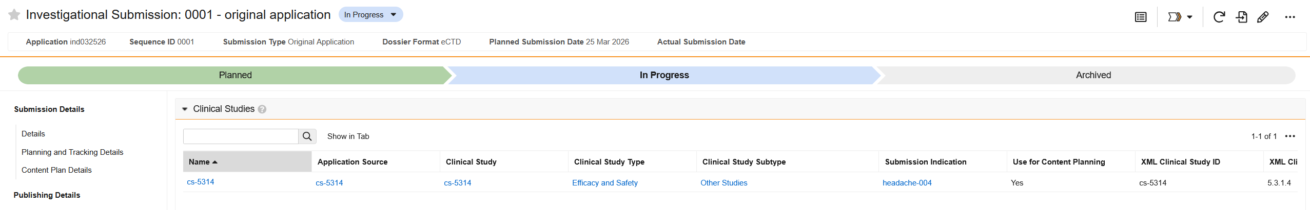
On the Submission record, to synchronize the Content Plan with the updates made to the submission relationships, run the ‘Update Content Plan’ user action:
You should get a notification when the update is complete:
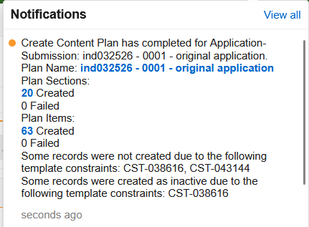

Then you can click the link in the notification to go to the updated content plan. You can utilize the show inactive if needed, but the study should now appear in the section 5.3.5.4 now:
